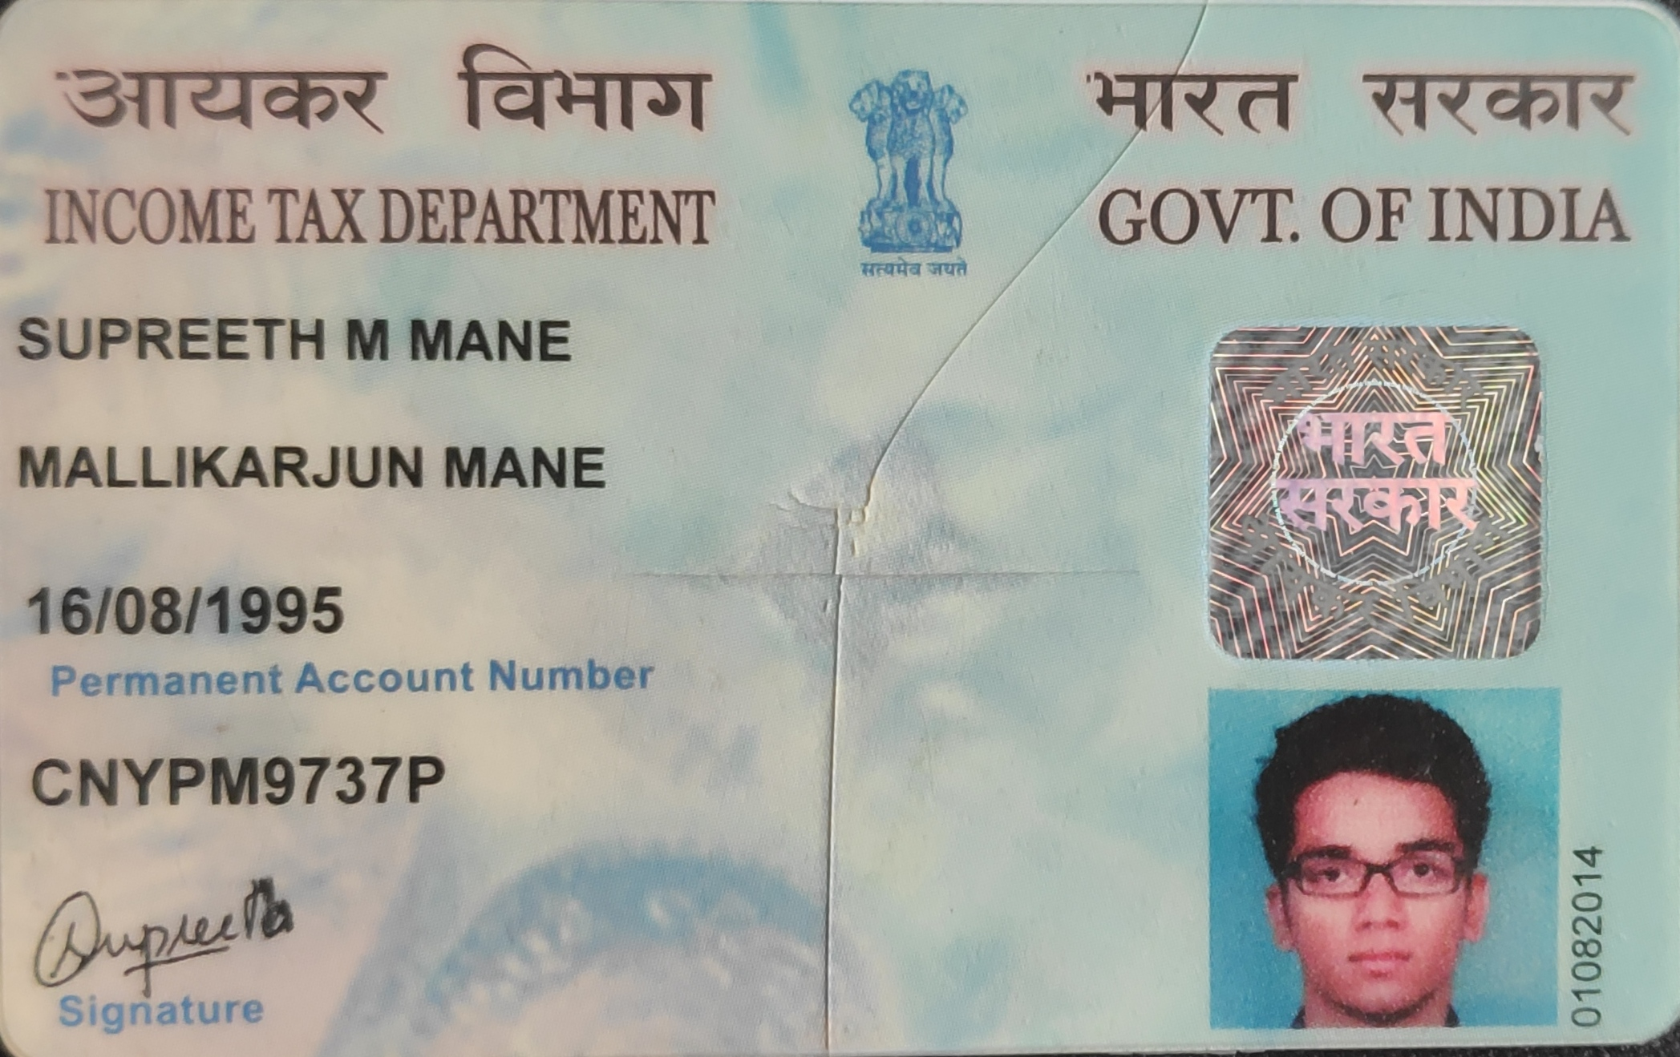

Candidate's Full Legal Name (as it appears on PAN)Vishal Nikam | Supreeth M Mane
Supplier Name (Registered Name) | People-prime Worlwide
Worked for CG previously? (IF yes share CG  Employee ID/GGID required | No
JOB Posting ID | CGEMJP00347212
Contact No (10 Digit No) | 8073157938
Email ID | supm29@gmail.com
Job Location (Work Location)
Notice Period (Immediate/ Notice to Serve) | Bangalore
Highest Education (Regular or Distance) | B.E
Employment Detail – Last 2 yrs Working period  (Payroll Company) | Infogain – Charitable Impact
College & University Full Name - | Atria Institute of Technology
Mandatory Skills & Experience  (quick checklist – verify each skill, years of  experience) | UX designer- 8Years
“Secondary” Skills & Experience | Atomic design– 8Years
Key Remarks (Supplier Comment) | Candidate Good at Communication Skill. He has experience of 8 years.
Supreeth M Mane | Senior UI/UX Designer
supm29@gmail.com I +91 8073157938 I Bengaluru, KA, IN
Links: LinkedIn Profile | Portfolio Website

SKILLS/ TECHNICAL
Skills: User Research, Usability Testing, Wire-framing, Journey Mapping, Rapid Prototyping, Information Architecture, Design Systems, Project Management, Team Leadership
Design tools: Figma (Proficient), Jira, Framer, Adobe CC (Photoshop, Illustrator, After Effects, Premiere Pro), Protopie, HTML, CSS, JavaScript

PROFESSIONAL SUMMARY
UI/UX Designer with 8 years of experience designing user-centered, data-driven digital experiences for web and mobile applications. Strong expertise in design thinking, user research, interaction design, and usability testing, with hands-on experience in designing AI-powered product features and intelligent workflows.

PROFESSIONAL EXPERIENCE
Infogain – Charitable Impact Bangalore
Senior UI/UX Designer Aug 2025 –April 2026
- Designed and delivered a social feature within the app to improve user engagement and community interaction, collaborating closely with product and engineering teams.
- Contributed to the design system, creating and maintaining reusable components, styles, and interaction patterns to ensure consistency across web and mobile experiences.
- Worked on website maintenance and UI enhancements, improving usability, visual consistency, and performance across multiple pages.
- Translated product requirements and user needs into high-fidelity wire-frames and prototypes using a user-centered design approach.
- Conducted UX refinements based on feedback from stakeholders and internal reviews to optimize user flows and interactions.
- Partnered with cross-functional teams to ensure design feasibility, accessibility, and scalability throughout the product life-cycle
- Used Atomic design to create design system and update them.

Nalashaa Solutions Pvt limited Bengaluru
UI/UX Designer Jan 2023 – July 2025

- Led end-to-end UI/UX design for web platforms, including websites, dashboards, and interactive prototypes, focused on usability, engagement, and performance.
- Designed data-driven visuals such as thumbnails, infographics, and dashboards, improving CTR, engagement, and clarity of complex information.
- Conducted A/B testing and iterative design optimizations to enhance user experience and overall product effectiveness.
- Contributed to design system development and supported content creation, SEO-friendly updates, and social media assets to ensure brand consistency across channels.

Wildcraft India Pvt limited Bengaluru
Designer May 2020 – Dec 2022

- Led end-to-end UI/UX design initiatives to support brand growth, user engagement, and conversion across digital platforms.
- Designed and maintained user-centric visual systems for marketing and e-commerce experiences, aligning brand identity with usability best practices.
- Created interactive digital assets including website interfaces, motion visuals, and social media experiences to enhance product discovery and engagement.
- Collaborated with marketing and business teams to translate goals into intuitive user flows and high-impact design solutions.

Knackbout Studios Bengaluru
UI/UX Designer Oct 2018 – March 2020

- Designed game UI and interaction flows for 3 digital games (SODR, Project Orb, and Big Bounty Smash), focusing on usability, clarity, and player engagement.
- Created user-centric experiences for 2 websites, ensuring intuitive navigation, visual consistency, and responsive design.

EDUCATION
Atria Institute of Technology Bengaluru
B.E in Mechanical Engineering 2014 - 2018

